1. Introduction

1.1 Purpose

To explore, design, implement and test a playable 2D multiplayer game using the .NET technology, the C# language, and the OpenTK libraries. Our project will be a turn based strategy game known as Chinese Checkers.

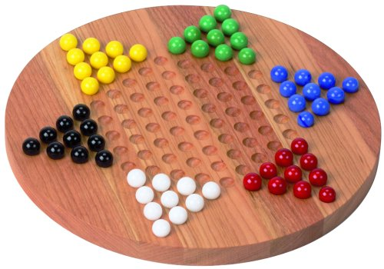

The goal of Chinese Checkers is to get all of you marbles from your starting position to the starting position of the opponent opposite from you. Pieces are able to move to any open space and may skip over other pieces if there is an open space behind it.

We chose this kind of project because we are both interested in designing and implementing our own 2D game that is playable over a local area network(LAN). We would both be able to create something we enjoy which would in turn inspire passion for the project.

1.2 Team contact information

1.3 Description and Scope

As mentioned above, the goal of our game is to fully transfer all your pieces to the starting position of your opponent opposite to you. Pieces are able to move one space at a time, unless you are able to skip over other marbles with an empty space behind them, players are able to chain these skips together if possible. This is a turn based game played off a hex grid board.

The game will have the following limitations:

* The game will be 2D
* The game will end when one player transfers all pieces to their final position
* The game will only be multiplayer
* The game will not have a leaderboard
* The game will not have any scoring
* The game will only be playable with even number of players (2,4,6)
* The game will only be playable over LAN
* The game will not have save/load states

2. Project Proposal

2.1 Existing Systems

While Chinese Checkers has been around since 1892 under the name "Stern-Halma", we wish to implement a newer version in which 2 or more players can over a network.

2.2 Proposed Solution

1. TBD